**Lab 10 Computer Networks**

Name: Tanvi Penumudy

Enroll No: E18CSE187

Batch: EB06

**CONTENTS:**

* Objective (Question)
* Procedure and Documentation
* Screenshots

**OBJECTIVE (QUESTION):**

Implement Open Shortest path first protocol on the given network. For providing IP addresses to given network devices, select a Class B IP address and use VLSM technique to save IP addresses.

**PROCEDURE AND DOCUMENTATION:**

* The OSPF (Open Shortest Path First) protocol is one of a family of IP Routing protocols and is an Interior Gateway Protocol (IGP) for the Internet, used to distribute IP routing information throughout a single Autonomous System (AS) in an IP network.
* In order to get started, initially set up the network as shown in the question.
* Configuration of OSPF is super Easy and very simple. As compare to any other routing protocols like[RIP](https://w7cloud.com/rip-routing-information-protocol-quiz-questionsanswers/), [EIGRP](https://w7cloud.com/features-of-eigrp/) you are required the following basic steps to enable OSPF on a router.
* Enable OSPF on Router by using command OSPF PROCESS-ID
* Define the interfaces on which you want to advertise in OSPF, you can done this with IP ospf command at interface level.
* Define Router ID
* On the router, enter the global configuration mode and configure the hostname as shown in the chart. Then configure the console, virtual terminal and enable passwords. Next configure the interfaces according to the chart.
* Router>enable
* Router#conf t  
  Router(config)#hostname Router0  
  Router0(config)#interface gigabitEthernet 0/0  
  Router0(config-if)#ip address 192.168.44.1 255.255.255.0  
  Router0(config-if)#no shut  
  Router0(config-if)#exit  
  Router0(config)#interface gigabitEthernet 0/1  
  Router0(config-if)#ip address 192.168.55.1 255.255.255.0  
  Router0(config-if)#no shutdown
* Configure the other routers in the same manner.
* PC0 Configuration: Assign the IP address, subnet mask and gateway. 255.255.255.0 is the Subnet mask and gateway will be the next hope address of router or the IP of router-interface attached with PC, and in this case it is 192.168.44.1. Each workstation should be able to ping the attached router.
* Similarly configure the others
* Configure an OSPF routing process on all routers. Use OSPF process number 1 and ensure all networks are in area 0. For configuring any router with OSPF you need to advertise all the directly connected network in OSPF process. For example on router0 you have the networks 192.168.44.0/24 and 192.168.55.0/24 so you can see that I have advertise these network in area 0 for OSPF configurations.
* Router0 OSPF Configuration:
* Router0#conf t  
  Router0(config)#router ospf 1  
  Router0(config-router)#network 192.168.44.0 0.0.0.255 area 0  
  Router0(config-router)#network 192.168.55.0 0.0.0.255 area 0  
  Router0(config-router)#exit
* Similarly configure the others.
* Hence we have successfully implemented this lab!

**SCREENSHOTS - IMPLEMENTATION:**

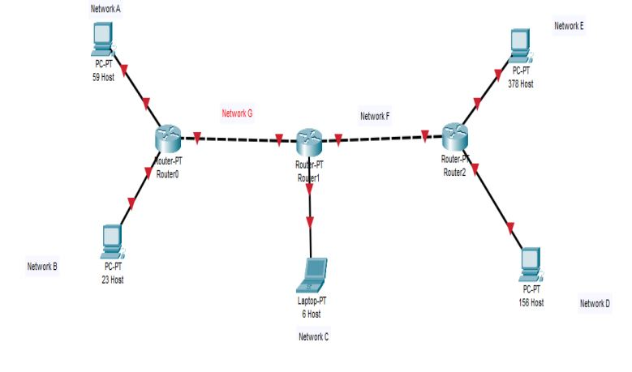 continued..

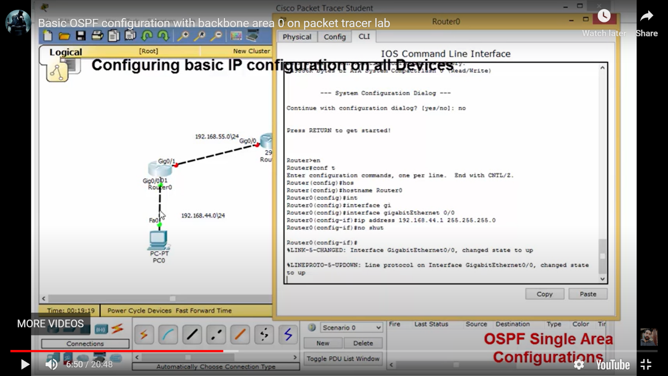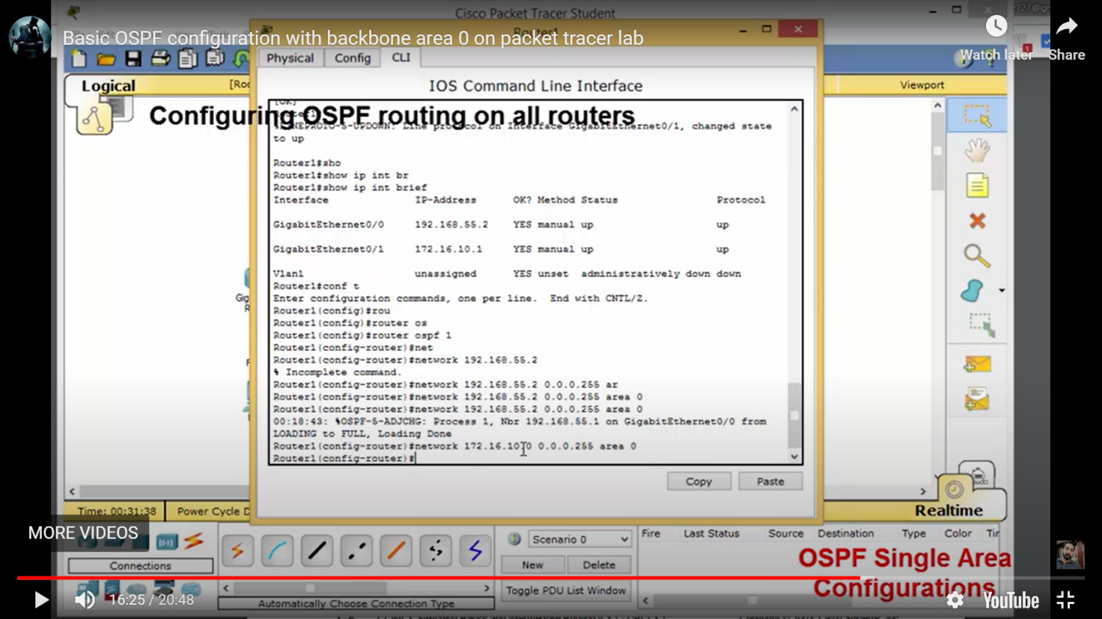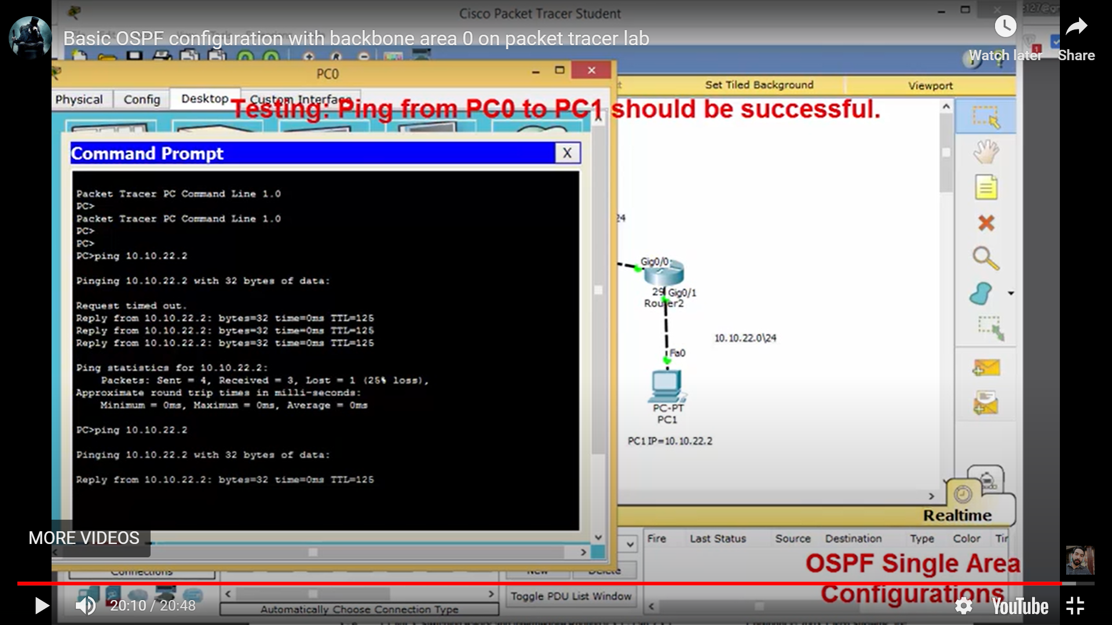continued..

